Course Settings
Administration Section

Table of Contents
Adding a Course 3
Adding a Section to a Module 6
Adding a Page to a Module 6
Inserting Text 9
Styling Your Text 9
CHANGING THE FONT 9
CHANGING THE FONT SIZE 10
CHANGING THE FONT COLOUR 10
CHANGING THE FONT BACKGROUND COLOUR 11
ADDING EMPHASIS TO TEXT 11
ADDING SUBSCRIPT OR SUPERSCRIPT 11
ADDING SPECIAL CHARACTERS 11
Changing Text Alignment 11
Inserting a Table 12
Inserting Images 14
Inserting Attachments 16
Removing Column Outlines 19
Add Activity 20
Add Test 26
Add a Certificate 30
Add a Glossary 32
Add Printables 33
Turning Your Course On 35
Edit Course 36
Review Course 37

As an Administrator for your company; you are able to add, edit and administer your courses in a number of ways.
Before we demonstrate how to administer courses, we should present two key terms to you.
Course: A course is an overall container for a module. A course can have one module, or many modules.
Module: A module is a component of a course. For example, “Safe Driving” could have multiple modules, such as driving rules, inclement weather, behaviours that influence safety, understanding road signs, etc. Having more than one module in a course is preferred for courses with heavier content that would be best broken down into parts.
To begin, we start off with accessing the Admin section via the Admin button at the top right side of your website. If you do not see this button, you may not have the proper administration privileges in the system.
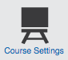

Once you are in the Administration section, click on Course Settings.

Adding a Course
An administrator has the ability to add company owned courses. To add a new course, select Add Course from the Course Settings page.
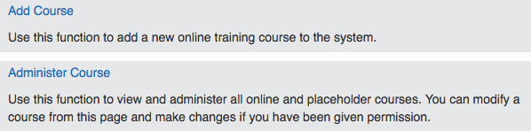
First you will need to choose what type of settings will apply to the course. Below is what each field means:
Country: Indicate the country that this course applies to. For example, Canada. If the module is generic, leave “All” selected.
Province: Select the province(s) that this course applies to. For example, British Columbia. If the information within the modules change for each province, you will need to create a separate course for each. If the module is generic, leave “All” selected.
Language: Select the languages you will offer this course in. If you offer the course in both English and French, you will need to input the French content after you input the English content, or vice versa.
Course Title: Enter in the title of your course in the languages you selected. These can be modified later if needed.
Course Description: Enter in a description of the course. This information is made available to learners on the training menu.
Keyword: Enter any searchable keywords you wish to add to this course. If one of these keywords is entered in the global search function, this course will be returned in the search results.
Service: Select the service(s) that this course belongs to. This is the training list that employees will be able to see the course under. For example, health and safety, human resources, wellness, etc.
Note: By designating a service to a course, you are only categorizing the course, not profiling it. To assign this course to users, please refer to the Configuration Settings – Administration User Guide, Edit Company Training Profile section.
Course Status: While you build your course, you will want to ensure you are building the course in an inactive status so the course cannot be assigned while being built.
Course Expiry: If you wish to add an expiry date to your course, enable it here. You can have the course expire within a time frame (for example, within one year from the date the course is taken) or by a fixed date (for example, the course expires January 1st annually).
Course Features: Enable the features you wish to be available within the course. You will need to keep module selected. Select certificate if you would like to create a certificate for the course, select glossary if you would like to create a course-specific glossary, and select printable if you wish to add downloadable resources to your course.
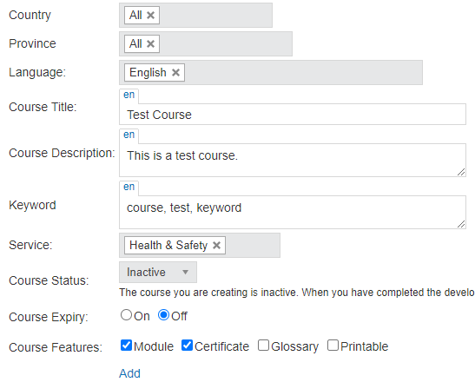
Once all fields are selected, select Add to add your new course. You will now be redirected to the Module List for this course. By default, the system has created one module for the course. If you need to add more modules to your course, simply select Add New Module, add in the name of your new module and select Save. Remember, you do not need to have multiple modules unless you feel they are necessary.
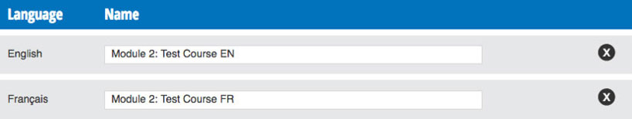
If you add another module and you wish to update the name of the module the system defaulted for you, simply select the pencil icon to edit the module name. Make the required edits and select Save.
Now you can begin building your module and inserting content. From the Module List, select the Module Builder icon next to the module you would like to edit.
Along the top of your screen is the module toolbar. If an icon is light grey, that means it is currently selected. In this example, we are in build mode so the first icon is a light grey.
Here is a breakdown of each tool:
Build Mode: You can add sections, pages, activities and tests in build mode.
Organize Mode: Use this mode to drag and drop and reorganize the placement of your sections, pages, activities and tests.
Display Mode: You can preview your course in a new window to see what it would look like to a learner.
Add New Section: Sections are helpful to group and organize module topics. Generally, the sections are consistent with your agenda or overview.
Add Page: Select this icon to add a new page to your module.
Add Test: You can have as many tests throughout the module as required but you must have one final test/evaluation located at the end of the module in order for the learner to be able to complete their module. You can add a variety of question types, such as multiple choice, true and false, matching, and multi-select.
Add Activity: A variety of activities are available to make your module fun and engaging. Use this option to add an interactive activity to your module.
If you selected to have more than one language while creating your course, you’ll notice at the top of the screen when you are building your module that there is a radial button to toggle between the languages available.
You will need to build a module in one language first and then build the module again in the other language(s). You need to ensure your module has a 1:1 ratio; meaning that each slide and section matches when you switch between languages – if the English module has 12 pages, so should the French, etc.

Adding a Section to a Module
The first step you will want to take when creating your new module is to add your first section.
To add a section, select the Add Section icon from the toolbar. Enter in the name of the section you wish to add. Section titles must be unique within a module. Click Save Section.
By default, the sections will be added following the previous section (if there is one). You can change the location of the section by selecting a new position from the location dropdown menu.
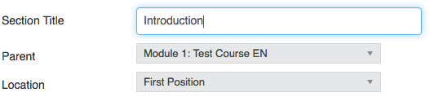
When you are done making your selections, select Save Section. Your new section has been added to the module navigation along the left-hand side of the page.

Adding a Page to a Module
Now that you have added a section to your module, it’s time to start adding pages.
If you have not added a section to your new module, please refer to the previous section, Adding a Section to a Course, for step by step instructions. You must add at least one section to your module in order to add pages.
To get started, select the add page icon from the toolbar to add a new page.
First, enter in the name of the page in the Page Title field. For example, Page 1, Slide 1, or Navigation 1. Next, you may upload a voiceover file in MP3 format if you have an audio file recorded already. Otherwise, you can always come back and edit the module and upload an audio file later. To do this, click Browse and find the file on your computer.
If you would like to display a helpful tooltip on the slide, enter the text into the Tooltip field. A little question mark will appear on the slide in the lower right-hand corner which will present helpful information when clicked by the learner.
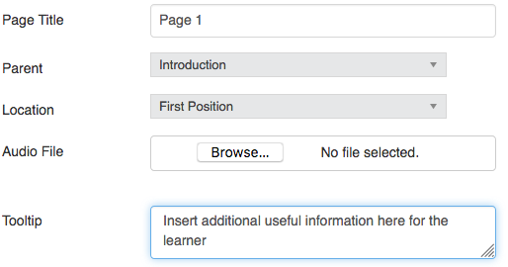
By default, you will land on the Themes tab. From here you can select your page template from the template options. You can choose from 4 different templates: Blank (best for full page images – 740px by 535px), Title Page, 1 Column Content Page, and 2 Column Content Page.
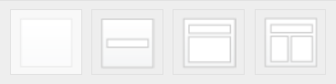
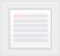
If you know your way around CSS, you can use the last template to modify universal styles in your page layouts. Not sure what to do with CSS? Back away slowly and switch back to one of the 4 templates.
In this example, we have selected the title page template.
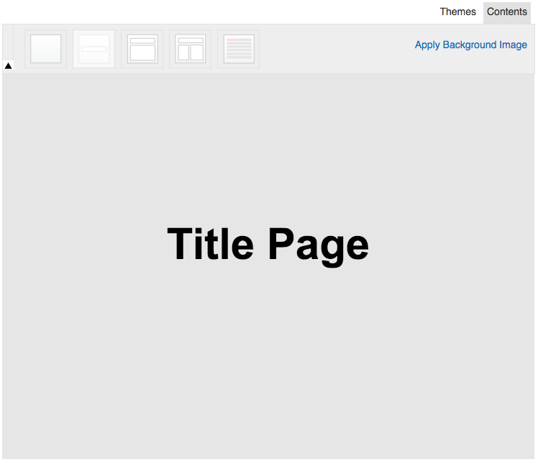
If you wish to apply a background image to your page, select the Apply Background Image option found just under the Themes and Contents tabs. It is recommended for background images to be 740px by 535px. This will ensure the background image fills the entire page size. Find the file from your computer you wish to apply and select Save.
Next, select the Contents tab to make changes to your selected template. From here you can add in text, images, links, and much more. There are also a variety of editing options available from the page toolbar, such as changing the font size, colour, alignment, etc.
Once you are finished designing your page, click Save Page to add the page to your navigation.
The following subsections will give you step by step instructions on how to use the different features in the page toolbar. We will start with the most common and work our way into more advanced tools.

Inserting Text
There are two ways to add text to a page: Manually Type or Copy and Paste. After selecting your page template, switch to the Contents tab.
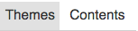
To manually type in your text, highlight the Page Title or Text Here and start typing.
To copy and paste unformatted text (no styles, colours, etc.), you can simply highlight Text Here and press Control + V on your keyboard (Command + V for Mac users).
To copy and paste formatted text (similar to the text in this user guide), you can highlight Text Here and press Control + Shift + V on your keyboard (Command + Shift + V for Mac user). This will remove any formatting and styles applied to the text and is called Pasting with Plain Text.
Here is an example of formatted text being copied and pasted using Control + V versus Control + Shift + V. The text on the left still has the formatting attached to it whereas the text on the right is now plain text and ready to style. It is recommended to always remove formatting from text for best viewing results.
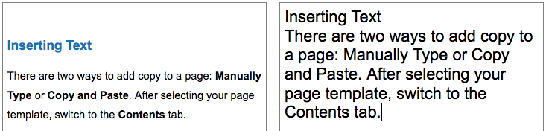

Styling Your Text
In this subsection, we will walk you through how to:
- Change the font and font size
- Change the font colour
- Change the font background colour
- Adding emphasis to text
- Adding subscript, superscript, and special characters

CHANGING THE FONT
To change the font, highlight the text and select a new font from the Font dropdown menu.
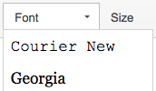

CHANGING THE FONT SIZE
To change the font size, highlight the text and select an appropriate font size from the Size dropdown menu.
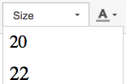

CHANGING THE FONT COLOUR
To change the font colour, highlight the text and select the Font Colour icon. Select a default colour from the dropdown menu.
If you don’t see a colour that you like in the default colour palette or if you want to use a specific branding colour to match your company, select More Colors.
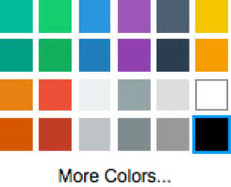
Choose a colour from the more diverse colour palette or insert the HEX code for your branding colour into the field above the Clear button. A HEX code is a 6-digit code made up of numbers and letters and starts with a hashtag. For example, #0c75ba. Once you have made your selection or entered in your HEX code, select OK.
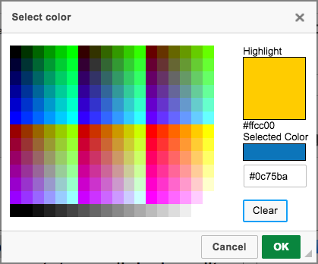

CHANGING THE FONT BACKGROUND COLOUR
To change the font background colour, highlight the text and select the Font Background Colour icon. Select a default colour from the dropdown menu.
If you don’t see a colour that you like in the default colour palette or if you want to use a specific branding colour to match your company, select More Colors and follow the same steps above.
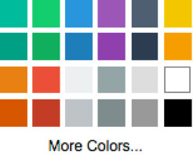

ADDING EMPHASIS TO TEXT
Adding emphasis to text is a great way to draw attention to something important. We offer the following: Bold, Italics, Underline, and Strikethrough.
To apply anyone of these settings to your text, highlight the text and select the appropriate icon.

ADDING SUBSCRIPT OR SUPERSCRIPT
In some cases, you may need to add subscript or superscript to your text so we have included handy tools to convert your text for you.
If you need to convert text to subscript, highlight the character and select the Subscript icon. This is handy when including a reference or source on a page.
If you need to convert text to superscript, highlight the character and select the Superscript icon. This is handy when talking about topics such as CO².

ADDING SPECIAL CHARACTERS
In some cases, you may need to add special characters to your page. For example, the copyright icon © or maybe a fraction ¼.
Select within your text where you would like to insert the special character and select the Special Characters icon. Click on the special character to have it added to the page.

Changing Text Alignment
A texts alignment can be set four ways: left, centered, right, and justified.
To change the text alignment, highlight the text you wish to update and then select the appropriate alignment icon.

Inserting a Table
To insert a table, select where on the page you would like to add the table and select the Table icon.
Choose how many Rows and Columns you will need by inserting the number in their respective places. The default Width is 500px but you can update this to fit your content. For a single column page, the max width is 665px. It is recommended to leave the Height of the table blank. By doing so, it will take on the height of the content inserted into the cells.
You can also select if the Header is the first row, first column, or both. This will automatically bold the text located within the cells.
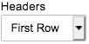
Setting the Alignment controls the alignment of where the table sits within the column, not the text within each cell. You can leave it to the default <not set> which will left align the table, or you can select left, centered, or right to secure its position.
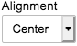
Cell spacing controls the spacing between each cell, whereas Cell Padding controls the spacing within each cell.
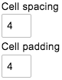
Lastly, you can control the Border Size of the table. The default is 1px but you can make this as thick as you want.
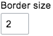
Once you are done making your selections, click OK to add the table to the page. Now it’s time to insert the content. At any point, you can update the settings by selecting the table and right clicking on it. Select Table Properties and make any necessary changes.
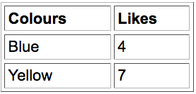
Now that you have inserted your table and the content, let’s go over some of the customization options. If you right click on the table, you can make changes to cells, rows, and columns by merging or splitting cells, or adding or removing rows and columns.
To change a cells background or border colour, select the cell you wish to edit and right click. Hover over Cell and select Cell Properties. Click Choose to select a colour. You can choose a colour from the provided colour palette or insert a HEX code. Once you have made your selection, click OK.
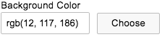
The field selected will update with the colour code chosen. To view the changes, click OK.
Depending on the background colour or border colour chosen, you may want to change the text colour for legibility.
To change the font colour, highlight the text and select the Font Colour icon. Select a default colour from the dropdown menu.
If you don’t see a colour that you like in the default colour palette or if you want to use a specific branding colour to match your company, select More Colors to make a selection.
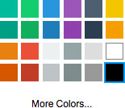
Continue adding content and making changes to each cell until you are satisfied with the overall design of your table. Get creative!
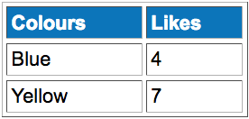
If you ever need to remove a table from the page, select the table and right click. Click Delete Table and the table will be removed.

Inserting Images
If you wish to add images to a page, select the Image Upload icon from the contents toolbar (location shown below).
After clicking the Image Upload icon, the image properties box will open. Click Browse Server to access the images folder.
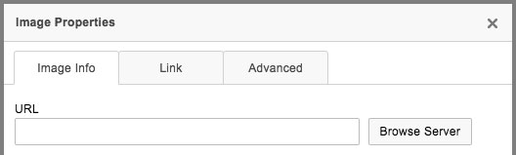
This is where you can find all images that you have uploaded to the server for this module. To add an image to the folder from your computer, select Add File and then click the Browse button. You can upload a single image or multiple images at a time.
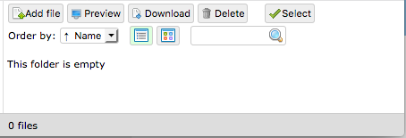
After selecting the image(s) you want to add, click Upload to have them added to the images folder. Your image has been successfully added once it turns green and says 100%. Click the X in the top right corner or select Cancel to exit out of the upload file window.
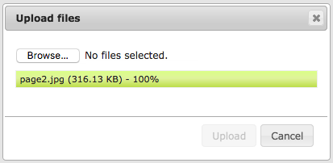
Double click on the image from the list of uploaded images to be brought back to the Image Properties box. From here you can adjust the size of the image by adjusting the width and/or height dimensions. You can also update the Alignment and determine if you want the image left or right adjusted. Select OK from the image properties box to add the image to the page.
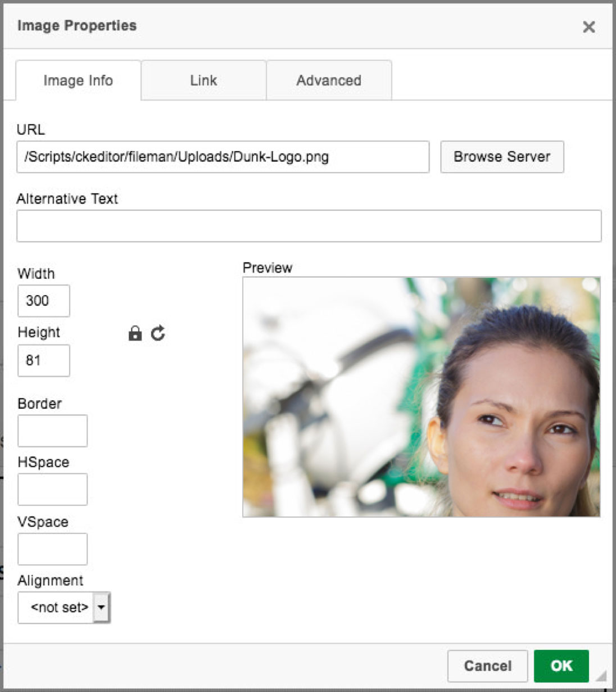
You can also resize the image after it has been inserted by clicking on the image. Once selected the image will be highlighted with a “bounding box”. Using your mouse, click on the corners to shrink or expand your image as needed to fill the necessary space.
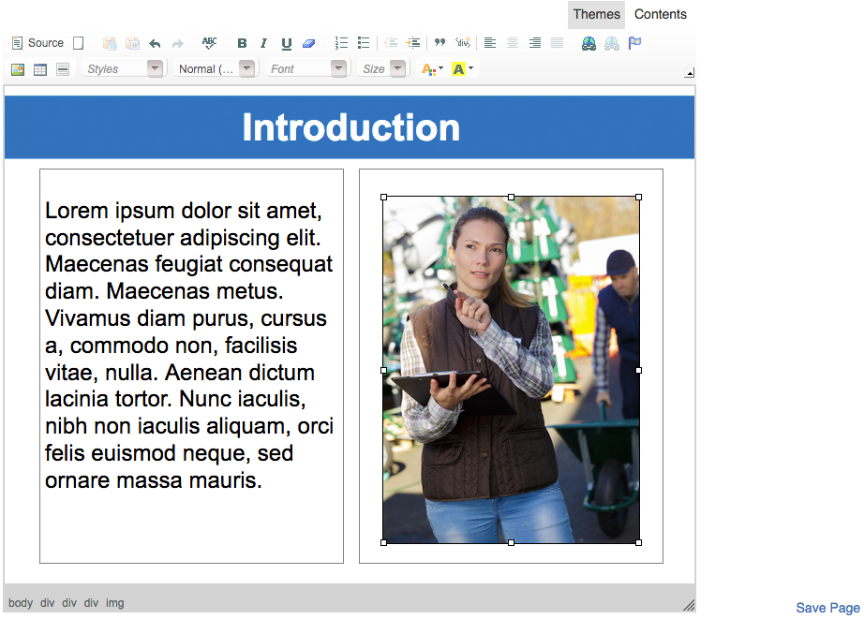
Click Save Page to add the page to your module navigation.

Inserting Attachments
On each page, you have the ability to insert attachments such as PDF files, Word documents, PowerPoints, etc.
After creating the page, highlight the text you want to turn into a link (such as “Click here”) and click the Link button (shown below).
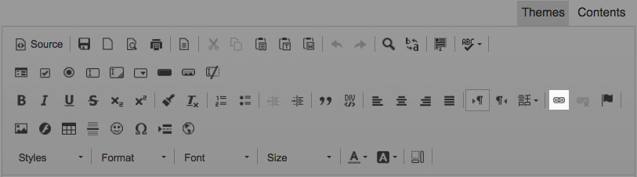
After clicking the Link icon, the link properties box will open. There are three Link Types to choose from: URL, E-mail, and Phone. Select the appropriate link type, for example URL, and copy and paste the web address into the URL text field.
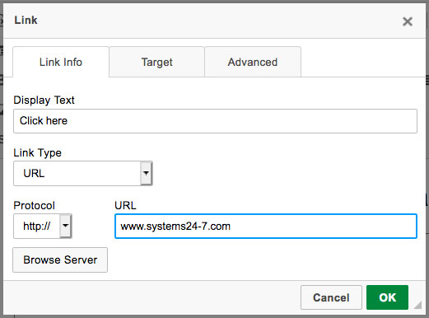
Above the link type is Display Text, this is how the link is displayed on the page. If you are attaching a document then this would most likely be the name of the document but if you were linking a long URL, instead of showing www.systems24-7.com/about-our-safety-groups you could shorten it to www.systems24-7.com as demonstrated below.
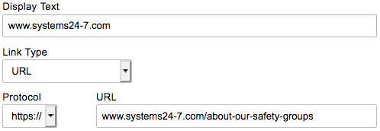
Now that you have added your URL, you will want to select how it opens. Select the Target tab from the Link properties box. Set the target to New Window (_blank). This will ensure your URL opens in a new window and not in the training window. Select OK from the link properties box to complete your request.
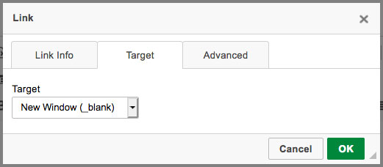
If you want to attached a document, for example a PDF or word document, click Browse Server to access the images folder. This is where you can find all images and documents that you have uploaded to the server for this module.
Upload your document by selecting Add File and then click the Browse button. You can upload a single document or multiple documents at a time.
After selecting the document(s) you want to add, click Upload to have them added to the images/document folder. Your document has been successfully added once it turns green and says 100%. Click Cancel to exit out of the upload file window.
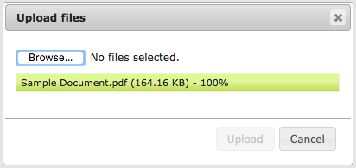
Double click on the document from the list of uploaded files to be brought back to the Link Properties box. You will see your URL has been updated with the path to the linked document.
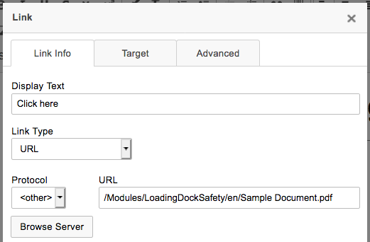
Select the Target tab from the Link properties box. Set the target to New Window (_blank). This will ensure your document opens in a new window and not in the training window. Select OK from the link properties box to complete your request.
The text you highlighted before clicking the Link button will now be blue and underlined. If you ever need to make changes to your link in the future, right click on the link and select Edit Link and repeat the steps above. If you want to remove a link, select Unlink.
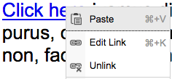
If you want to link an email to a page, it is important to select E-mail as the Link Type. This tells the system to open the users email server and start a new email message. The new message will pre-populate the data entered into the Link properties box. You can even add a specific subject line to know where the email is coming from, i.e. Employee Orientation Course.
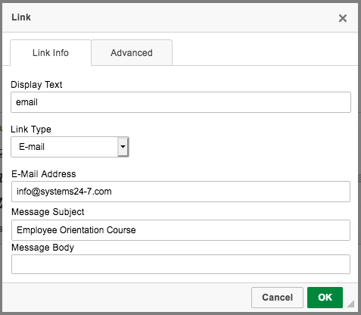
Select OK from the link properties box to complete your request. If you ever need to make changes to your link properties in the future, right click on the link and select Edit Link and repeat the steps above. If you want to remove a link, select Unlink.
Click Save Page to save your changes or to have the page added to your navigation.

Removing Column Outlines
Once you have added all your content to a page, you will want to remove the outlines found on the template pages so they do not appear in Display Mode. These outlines are added in Build Mode to help you with the layout of your page. Once they are no longer needed, follow these steps to remove them.
First, select the Source button found in the top left corner of the page toolbar (shown below).
This takes you to the code of your page. Near the top of the page you will see .left-column, .right-column, or if you are using a single column template, .content-div. Under each respective title you will see “border:1px solid grey;” which is the code that adds the outline to each column for designing.
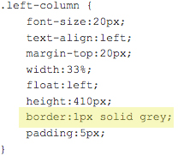
If you are feeling overwhelmed and having troubles finding this section of code, you can also use Find in this Page by pressing Control + F on your keyboard (Command + F for Mac Users). Type in “border” into the search bar and it will be highlighted within the code.
To remove the border, simply change “1px” to “0px”. If you are using the 2 column template, make sure you make this change twice under left and right column.
Next, select the Source button again to return to the front-end of the page.
The column outlines have been removed. Click Save Page to save your changes or to have the page added to your navigation.

Add Activity
To add an activity to a module, select the Add Activity button from the toolbar. Enter in the name of the activity and determine its location.
From the dropdown, select the type of activity you would like to insert. There are a number of defaulted activities available and each can be customized for font, colour choice and images.
Below are the types of activities available and then we will provide an example of creating an activity. To help you select the best activity, we have put a number between 1 and 3 beside each activity type to indicate the level of difficulty in creating the activity (1=easy, 2=moderate, 3=difficult).
Interactive Slides¹: This option provides you with an interactive slide. You can add a number of options for the user to select and be provided with some information related to the slide content. For example, if you have 7 steps to a lockout procedure, you may wish to create an interactive slide where the user can select each step and read about it.
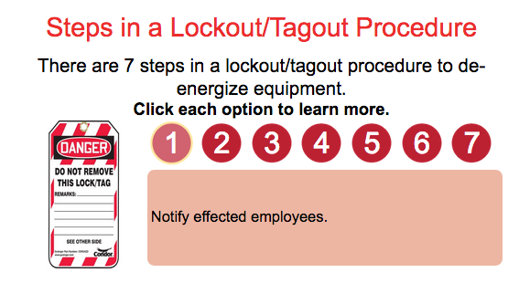
Select Two¹: This option provides you with a simple click and select activity. In this activity, the user needs to click and select the correct response. You can have as many right answers as you wish but you must have one incorrect option.
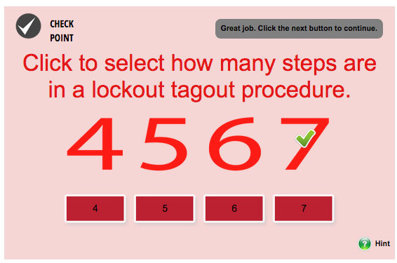
Click Remove²: This activity allows you to click and remove the statement that does not apply. This is a great activity to remove the incorrect step in a sequence.
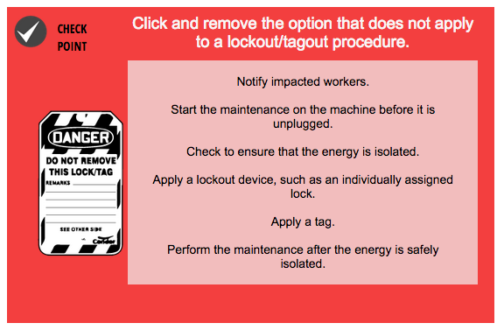
Learning Objectives¹: This activity is specifically designed to outline learning outcomes at the beginning of a course or section. Users will have to click and open each book (objective) from the book shelf to review their objectives or outcomes. Users cannot continue until each book is opened.
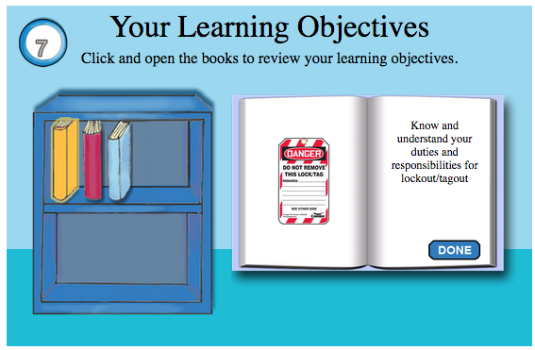
Select One¹: This activity provides you with a simple click and select activity. This differs from the first click and select activity as it provides more room for text on each option. In this activity, the user needs to click and select the correct response. You can have as many right answers as you wish but you must have one incorrect option. You can also choose whether the options should have an image or just be filled with a colour in the image area.
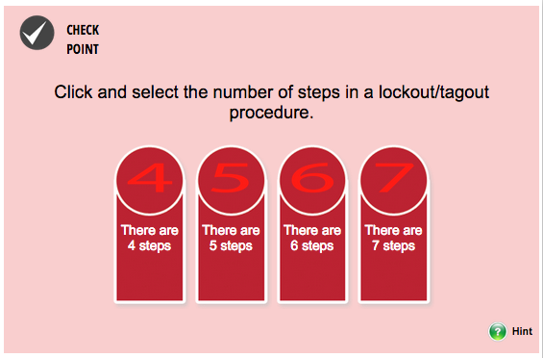
Drag Drop Match¹: This activity allows you to drag and drop options upwards to match them to their related category. You can also put text in the woman’s speech bubble to provide additional prompt and instruction.
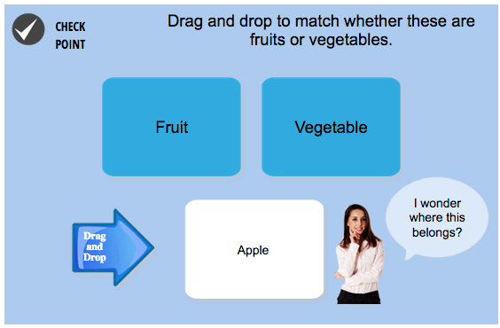
Drag Drop Scale²: This activity allows you to drag and drop options sideways to match them to their related category. This activity differs from the previous matching activity because instead of dragging and dropping the items into boxes, you drag and drop them onto a scale.
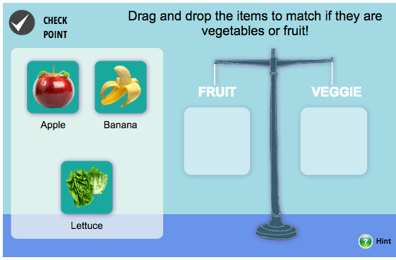
Drag Drop Bubble¹: This activity allows you to drag and drop options into a thought bubble. We like to use this activity to “remind Tom” how to do something.
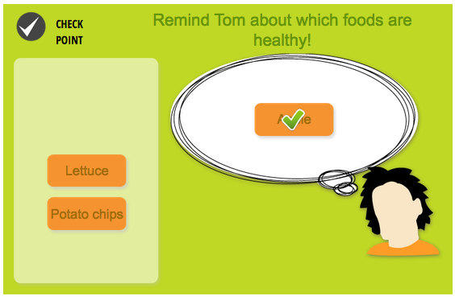
Click Appear³: This activity is great for diagrams that you want to label. You can click the correct options and have them appear on an image in the correct place. In the example below, we have clicked nucleus and the part of the nucleus is now outlined in red and applied to the diagram. Note: You will need to provide the images you want placed on the diagram and if you want them outlined or highlighted, this needs to be on the image you upload (it’s not done by the activity). In the activity settings, you will also need to adjust the top and left adjustment to ensure the image appears where you want it to appear in the diagram.
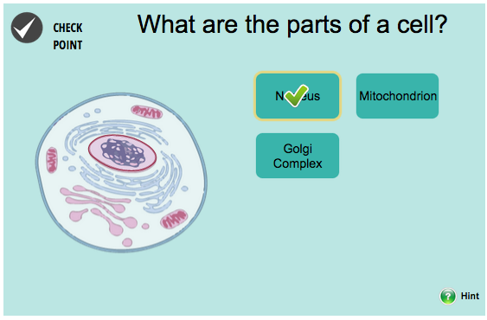
Now that we have reviewed each activity type, let’s create one with you. If you haven’t already, name your activity, select the location to add the activity and select the activity type. Once you are finished, click Save Activity.
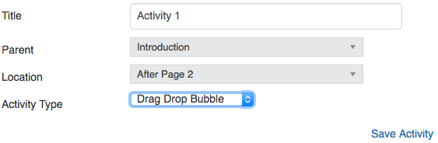
The activity will now be added to your Table of Contents. Select Add Questions to customize or edit the activity.
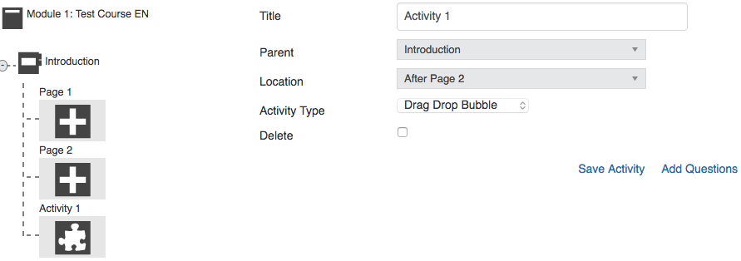
Enter in the activity details. There are a number of tooltips/prompts provided to reinforce learning to a learner. Below is what each field means.
Page Title: This is the question for the activity. For example, “Remind Tom of what the acronym RACE stands for by dragging and dropping the correct options to his thought bubble.”
Incomplete Tooltip: This is the response the learner receives if they try to click next without completing the activity.
Completed Tooltip: This is the response the learner receives when they have successfully completed the activity.
Correct Option Tooltip: This is the response the learner receives when they select the correct option (when there are multiple correct options to select).
Incorrect Option Tooltip: This is the response the learner receives when they select the incorrect option.
Hint Enabled: If you would like to add a hint to your activity to reinforce the correct answer, turn the hint on. If you do not want to have a hint, turn the hint off.
Background Colour: Customize the colour of your activity by changing the background colour.
Options Colour: Customize the colour of your activity options by changing the options colour.
Question Voiceover: Upload the voiceover to your activity. Don’t have a voiceover? Don’t worry, you can always come back and edit the activity later.
Apply Checkpoint Icons: Use this option to apply a checkpoint icon to your activity to remind learners this is an activity.
Number of Options: Select the number of options you wish to include in your activity. Some activities have caps on the number of options you can apply.
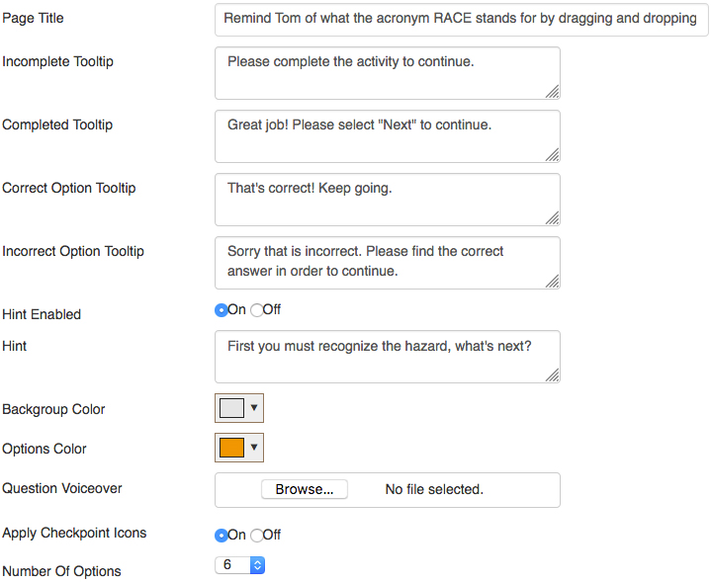
Note: Some activities have other text options to fill in. For example, the drag and drop to match activity allows you to put information into the talking bubble as seen in the example on page 23. When you get to the Preview step, you will be able to preview your text and see your activity come together.
Under the options section, enter in the information you wish to use. For some activities, you can change the Option Type to either an Image or Text. Select True to select the correct responses for the activity. Most of the time you can select one or more. In some of the other matching activities, you will instead need to select where the option matches to.
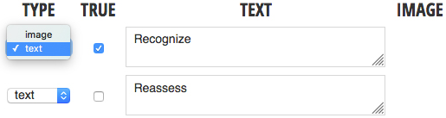
Once all options are entered and correct responses are selected, select Save Question at the bottom of the page and then select the Theme tab. Under the Theme tab, you can change the fonts, font sizes and colours. If you don’t update any of the theme options then they will default to the systems selection. Make any required changes and select Save Question Theme.
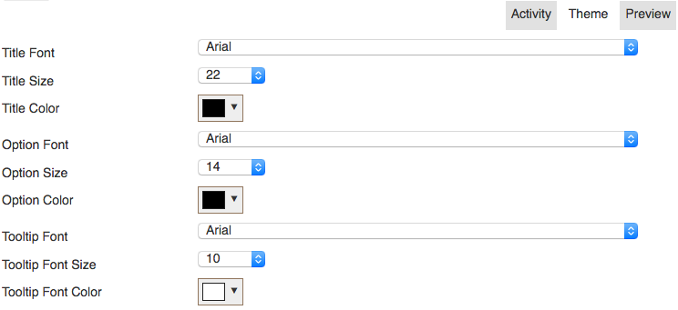
You can change to the Preview tab at any time to see how it looks and then toggle between the tabs to make changes. Remember, anytime you make a change, you must click the Save button. Once you are satisfied, you may click any icon from the course toolbar and continue to add more activities, tests, pages, etc.

Add Test
To add a test to a module, select the Add Test icon from the course toolbar options.
You can have as many tests throughout the module as required, but remember, you must end each module with a final test. This is required and there must be no pages following the final test.
Enter in the information about the test you wish to create, including the title and position. You can customize the passing score for each test added. In this example, we are using a passing score of 100% which means the learner must get every answer correct in order to pass the course. If it is a final test, ensure you select Is Final Test from the test options. Once all information is inputted, select Save Quiz.
If you could like the user to view their quiz or test results check the Show Test Result box. This will provide immediate feedback upon the completion of any quiz or test during training.
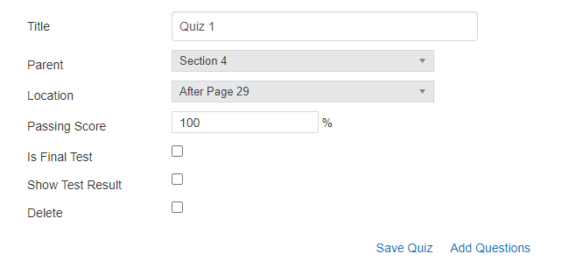
The test will now be added to your Table of Contents on the left-hand side. To add or edit questions to your test, select the test you added and click the Add Questions option. If you ever need to delete a test or activity, click the item you would like to remove and click the Delete selection box followed by Save Quiz.
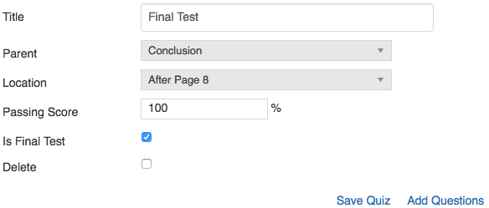
From the options available, select the type of question you wish to add to your test, such as multiple choice, multiple select, matching and short answer.
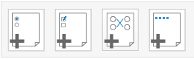
In this example, we will create a multiple-choice question. You can add as many questions to a test as you wish. Below is what each field means:
Question: Enter in the question.
Tooltip Enabled: If you would like the learner to be able to reinforce their learning with tooltips (meaning they are prompted to select the correct answer) enable the tooltips. In most instances, you will likely prefer to have these turned off.
Hint Enabled: If you would like the learner to be prompted with a reminder to help them answer the question, enable the hint.
Hint: Enter in the content for the hint.
Link to Page: Link the question to a page of your module to refer the learner back to that page to read the content again in the event they fail a test.
Audio File: Upload an audio file to read the question and answers.
Image Upload: Use this option to upload an image to the button of the test questions (for example, a diagram).
Is Correct Required: If the user must select the correct response to continue, enable this setting. Leaving it turned off means that they will not be prompted to select the correct response.
Display Question Numbers: If you wish for learners to be able to see the question number before each question, turn it on here.
Number of Questions: This feature allows you to number each test question added. For example, your first question added would be 1, your second question added would be 2, and so on.
Apply Checkpoint Icon: If you wish for the learner to be able to apply a checkpoint icon, enable it here.
Number of answers: Select the number of available responses.
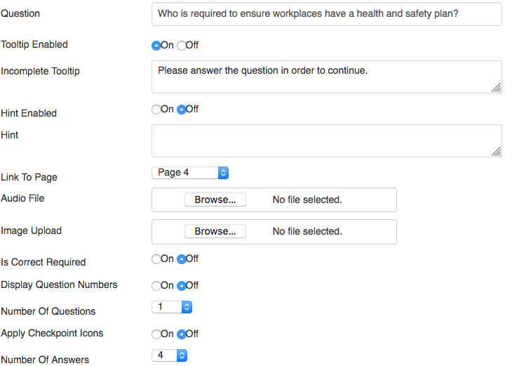
Under the answers section, enter in your answers and select the response which is True under the true column. For multiple choice questions, you can only have one true answer. For multiple select questions, you can have more than one true answer.
Assign a score to the response (such as 1) and select Save Question. A score is needed for the marking of your test. Incorrect options should have a score of 0, and correct options generally have a score of 1.
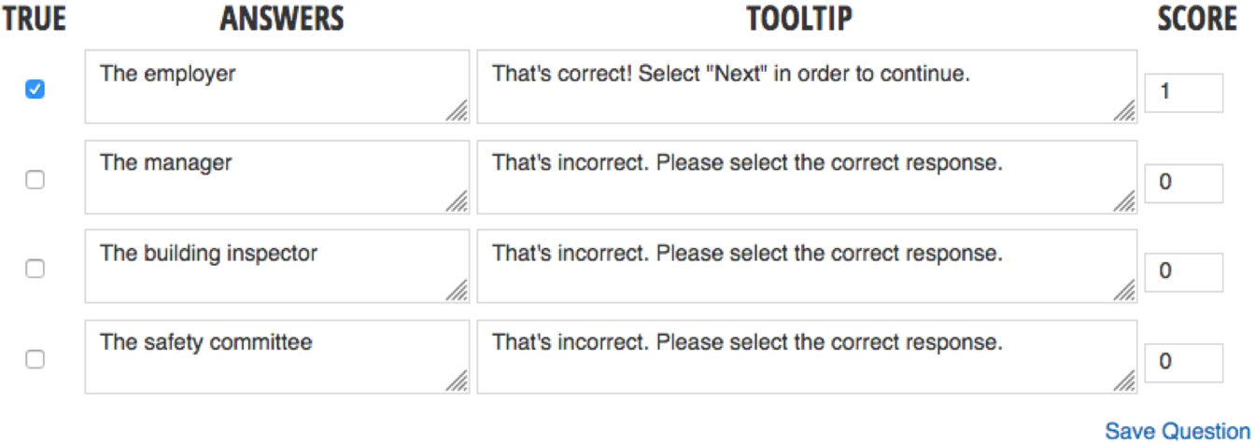
Once you click Save Question you will be brought back to the test overview page. To add another test question, select the test question type from the test toolbar and continue to add as many questions as necessary.
If you wish to edit the theme of a question, select the pencil icon next to the test question and select the Theme tab to change the font and colours of your question. Select Save Question Theme to save your theme changes.
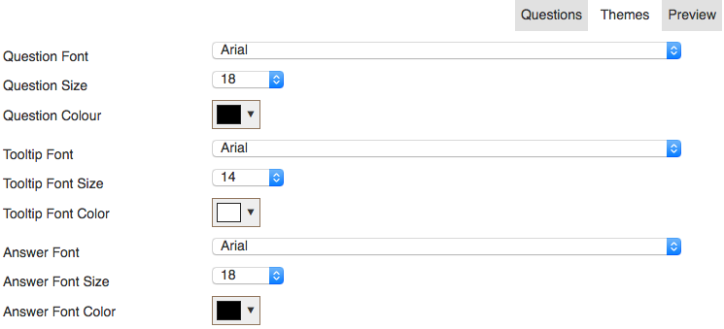
Select the Preview tab to preview your question. Toggle back to the Theme tab to make changes as you need to.
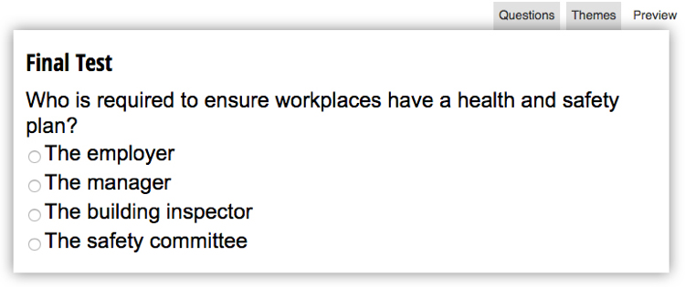
When you are finished, select Question List under the preview window to be brought back to the test overview page.
In your question list, you can reorder the questions as required using the drag and drop arrows. Reorder the questions as needed and click Save Order.
Once you have finished adding all sections, pages, activities and tests to your module, you must now upload the module in any other languages you have selected to be available, keeping the 1:1 ratio.
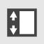
As previously mentioned, you can reorganize your sections and pages by selecting the Organize Mode from the toolbar. By clicking the organize icon, all sections, pages, tests and activities will have a drag and drop icon appear. Simply drag and drop to reorganize the module and click Save Order to save your changes.
To preview your course, select the Preview option.

You can select the Back to Module List option to continue to build any other required modules within the course as needed.

Add a Certificate
Once you have finished building your module(s), you can apply a certificate, should one be activated. When the learner completes a course with a certificate, they will be able to access their certificate off their training page and administrators will be able to access certificates in their reports.
To add a certificate, go to Administer Courses under Course Settings. Find the course you would like to add the certificate to and click on the Course Home icon.
If you are already in the module you would like to add the Certificate to, click the Back to Module List option.
From the course home page select the Certificates tab, found under the course title, to add a certificate. After a certificate is added, you can edit it at any time by selecting the certificate tab from the course home page.
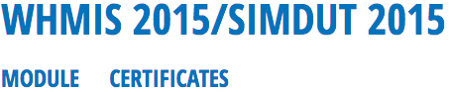
On the left-hand side, select the certificate size you wish to create, such as a letter size, wallet or letter and wallet. Once these are selected, you’ll be able to use the Template tab to select your template.
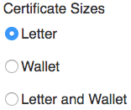
There are two templates to choose from: Certificate without signature fields (left icon) and certificate with signature fields (right icon).
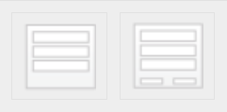
In the example below, we have selected the second signature template, Certificate with Signature Fields.
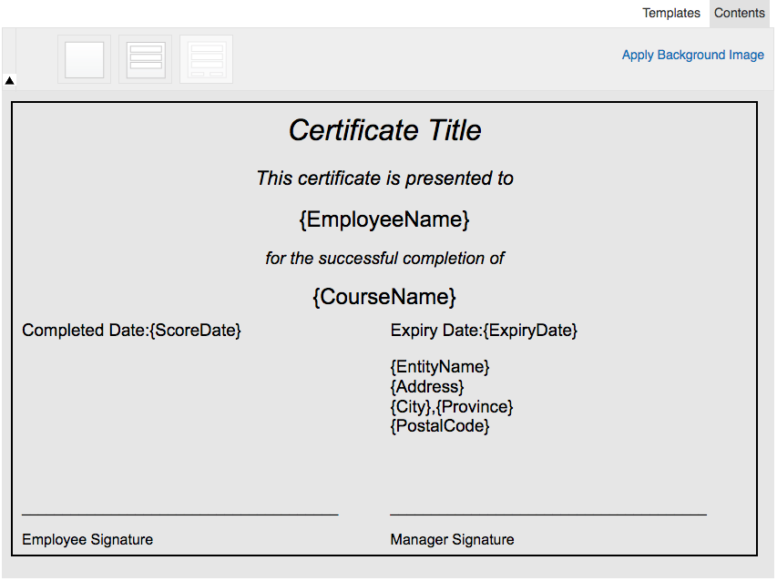
Next, select the Contents tab to edit the contents within the certificate. You can change the text within the certificate and upload images as needed. Once you have made the required changes, select Save Certificate.
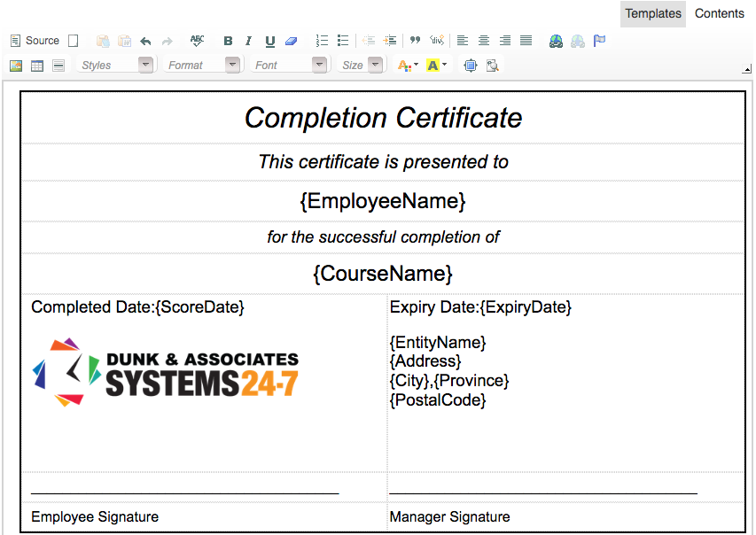
Note: It is important not to remove any {placeholder text} located within these brackets ‘{ }’. The system uses the placeholders to populate data based on the specific user it is supply the certificate to. For example, {Employee Name} will be replaced with “Joe Smith” when assigned to Joe.

Add a Glossary
When you added your course, you selected whether or not you wish to have a glossary added. The course glossary displays any terms used within your course and modules. The glossary applies to the entire course, so if your course has multiple modules within it, you only need to have one glossary.
To add items to your glossary, ensure that the glossary feature is turned on in the course settings.
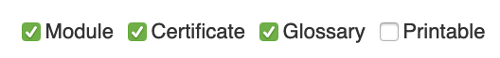
From the course homepage, select the glossary option at the top of the screen.
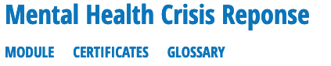
Depending on the languages enabled for your course, you will have the ability to add your glossary in the different languages. Select the language you would like to add the term to. If you have English and French, for every English term you will want to later add the same term in French.
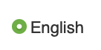
Select the Add Term button to add a term to your glossary
Enter in the term and the definition and click save.
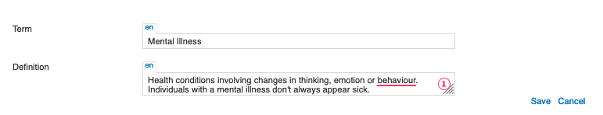
Your term is added to the term list. From the term list you can edit the term and delete it by selecting the edit and delete options.
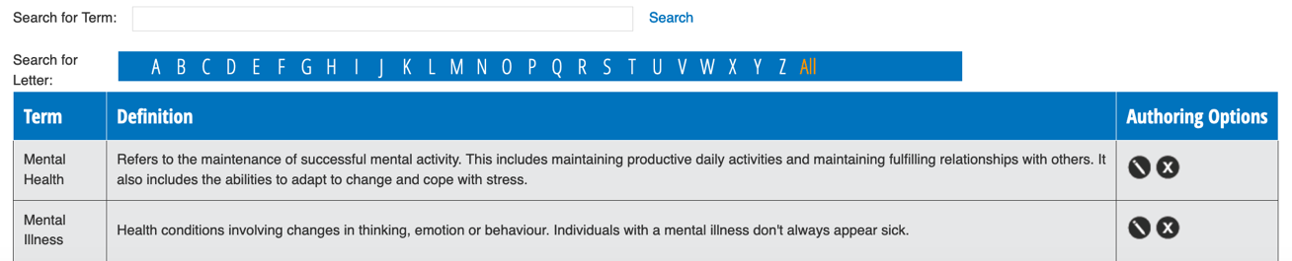
Added terms are displayed to learners under the glossary option of the course in their table of contents. Learners can also search for terms within the glossary if they are unfamiliar with them.
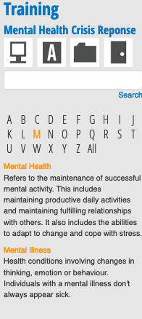
When you are done, if you have other languages enabled, swap the language of your glossary and add the terms in the other languages.

Add Printables
When you added your course, you selected whether or not you wish to have “printable” resources added. The printables feature allows you to add downloadable content to your course, such as forms, files, an audio script, powerpoint presentation, posters, or other resources. Like the glossary, the printables feature applies to the entire course, so if your course has multiple modules within in, your printables are available to all modules. If you want to create folders specific to each module to organize your printable materials, we will explain how to do this.
To add items to your glossary, ensure that the glossary feature is turned on in the course settings.
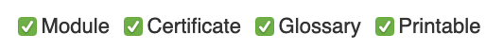
From the course homepage, select the glossary option at the top of the screen.
Depending on the languages enabled for your course, you will have the ability to add your printables in the different languages. Select the language you would like to add the items to. If you have English and French, for every English printable you will want to later add the same document in French.
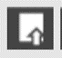
There are a few buttons available.
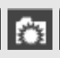
Upload Documents allows you to add a printable resource to your course.
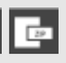
The Add Folder option allows you to organize and create folders to add your printables within.
The Export Documents option allows you to export all uploaded files.
If your course has multiple modules within it, or if you have a lot of printable materials, you may wish to create files or folders to better organize your printable documents. To add a new folder, select the Add Folder button.
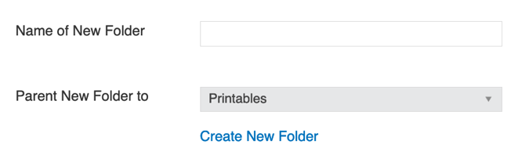
To add the new folder, enter in the folder name and select where the folder should go. If you already have folders set up, you may wish to locate this folder below another folder. When you are done, click Create New Folder to save.
You will receive a prompt to confirm the folder is added. Click the back button to return to your printables, or select the Upload Documents button to begin uploading a printable.
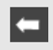
To add a new printable, select the Upload Documents option.
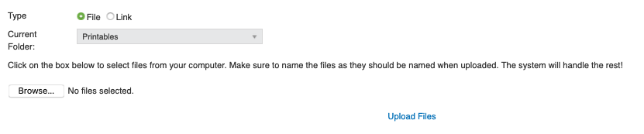
You have two options when uploading printables, to upload a file or to use/create a link.
To upload a file, select the browse button to find the file you want to upload to your course. Name the file as you would like it to appear online, and the system will do the rest! If you don’t name it properly, don’t worry, you can edit the printable afterwards and change the file name (and add a description too if you want one).
To create a link, select the link option. Provide a title for the link, such as the name of the website.
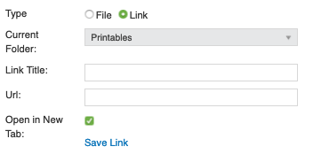
Add the URL (web-address) for the website and select whether to open the link in a new tab. So users are not directed away from your website, it is best to keep this option selected.
You will receive a prompt to confirm the printable is added. Click the back button to return to your printables list when you are done uploading all printables.
From the printables list, you can edit documents (change their name and/or add a description), move them to another folder, hide them, and delete them.
Added printables are displayed to learners under the printables option of the course in their table of contents.
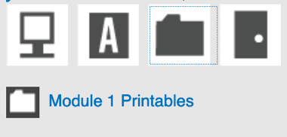
When you are done, if you have other languages enabled, swap the language of your printables and add the resources/documents in the other languages.

Turning Your Course On
Now that you are finished, your final step is to make your course and modules live. Return to the module list page by selecting Back to Module List.
From the module list page, select the eye icon to activate the module(s). The icon will turn blue and now the modules are live.
Next, select Back to Administer Courses to return to the Administer Courses page.
From the Administer Courses page, find the course you would like to go live. Activate the course by clicking on the eye icon again.
Your course is now complete and ready for assignment. To assign this course to users, please refer to the Configuration Settings – Administration User Guide. Read and follow the steps in the Edit Company Training Profile section.

Edit Course
An administrator can make any required edits or changes to a company-owned course at any time. To edit a course, select Administer Course from the Course Settings page.
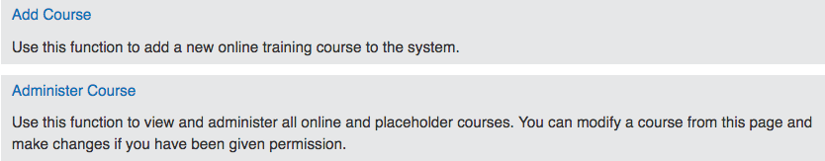
A variety of filters are available for you to search for your course. Use the filters to narrow down your results or type the course name into the Course Name field followed by Search.
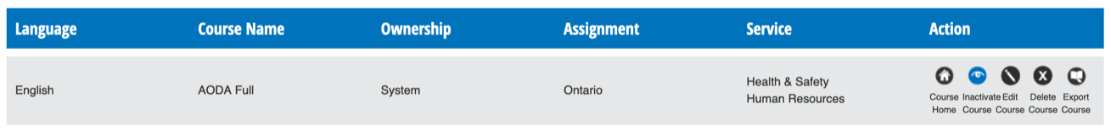
Once you have searched for your course, there are a few icons to familiarize yourself with from the Administer Course Page:
Select the course home icon to enter into the course and begin adding/editing modules within your course.
The eye “open” shows you that the course is Active. This means that the course is on and visible. To deactivate the course, select the icon and the eye will “close”. You may wish to do this if you are making extensive changes to a course. In this case, we recommend setting the status of the course to inactive to turn off your course from viewership. This will temporarily turn-off a user’s ability to access the course while you make any required updates. Please note, making a course inactive temporarily hides the course from a user’s profile and also hides it in the reports.
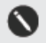
To edit a course name and the details regarding the course, such as the description and assigned province, click the edit icon from the administer courses page.
Select the delete icon to delete the course. This cannot be undone.
Select the export icon to export all course files. Doing this will export your images, audio files, and course slides.

To edit a module, select the Course Home icon.
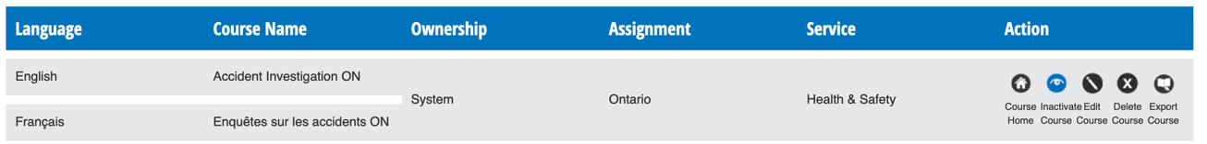
From the module homepage you have a variety of options:
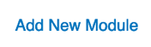
If there is a certificate turned on, you can update the certificate by selecting the certificates button.
You can add a new module by selecting the “Add New Module” button.
You can select the build icon to edit/build the module’s content, activities and tests.
You can select the edit icon to edit the module name.
You can deactivate the module by selecting the eye icon and closing it.
You can delete the module by selecting the delete icon. This cannot be undone.

Once inside a module, from the module navigation located on the left-hand side of your screen, select the page, activity or test you wish to edit. Make any required changes and select Save.
For help with making changes to activities and tests, please refer to the Add Activity and Add Test section of this user guide for step by step instructions.

When you have completed all changes, reactivate the course (if applicable). To do this, select Back to Module List and then Back to Administer Course to find the course.
Reactivate the course by selecting the eye icon from the administer courses page. Learners will now be able to access their course again.

Review Course
You can review or export any courses that your company has access to by using the Review Course tool. To review a course, select Review Course from the Course Settings page.
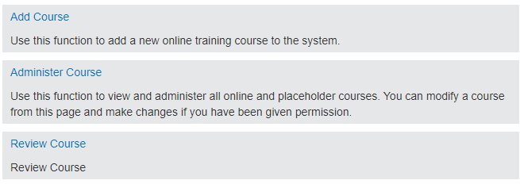
A variety of filters are available for you to search for your course. Use the filters to narrow down your results or type the course name into the Course Name field followed by the Enter key on your keyboard.
The course list is very similar to the list found in the Administer Course tool, except that you will only have two options for each course: Course Home and Export Course.
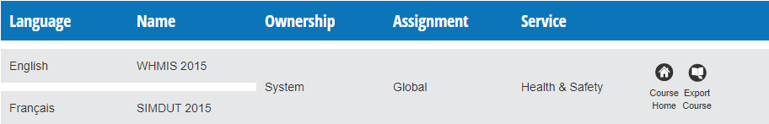
The Course Home button will take you to a screen where you can preview the course in a new window, to see what it would look like to a learner.
The Export Course button will export the course into a zip folder containing a PDF file. You can then save or print this PDF file.
To preview the course, click on Course Home. You can then preview the course in all available languages:
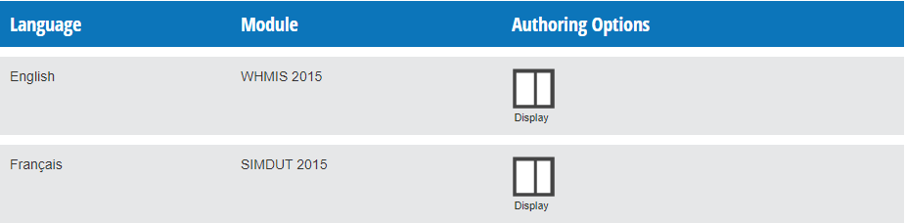
To preview the course, click the Display button. This will open the course in a new window, and you can preview the course to see what it would look like to a learner.
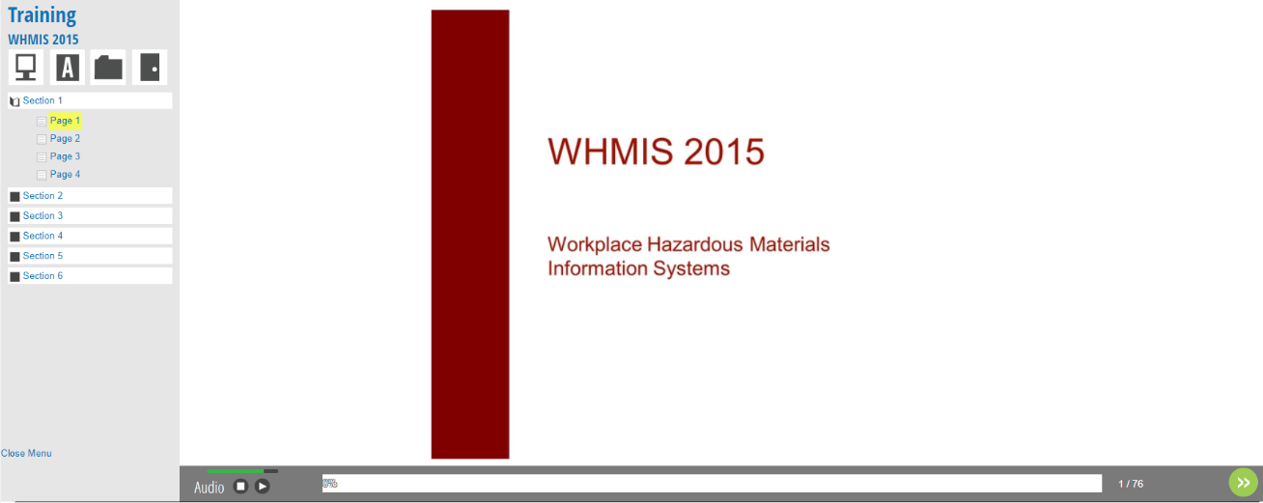
To export the course into PDF format, click the Export Course button from the main Review Course page. The system will begin the export process. When this process completes, you will be prompted to save the file:
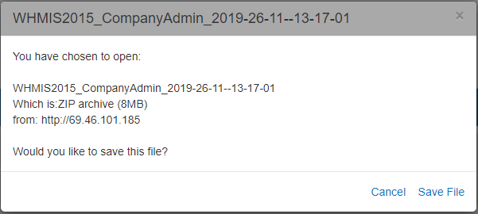
Once you click Save File, a zip folder will be downloaded to your computer. Inside the zip folder will be a PDF file containing the course.

